**Lab Exercise 01**

**Creating Static Host Inventory**

Jahnavi Anand

500106908

**Objective:** To create a static host inventory for managing and automating infrastructure tasks efficiently across multiple servers using Ansible

**Tools required:** Ubuntu OS

**Prerequisites:** You need to have Ansible installed to proceed with this demo

Steps to be followed:

1. Generate SSH key pair on the main node
2. Copy the SSH key to the two other nodes
3. Update the inventory or host file with the host IP address
4. Establish connectivity between the hosts specified in the host file and the Ansible server

**Step 1: Launch EC2 Instance**

1. Go to AWS Console → EC2 → Launch instance
2. OS: Ubuntu 22.04 or similar
3. Instance type: t2.micro (Free Tier)
4. 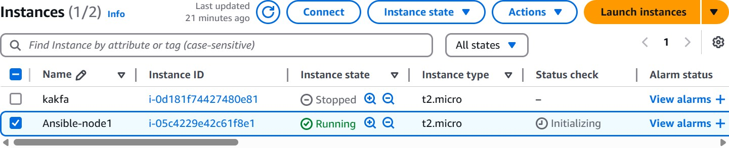Enable port 22 (SSH) in Security Group

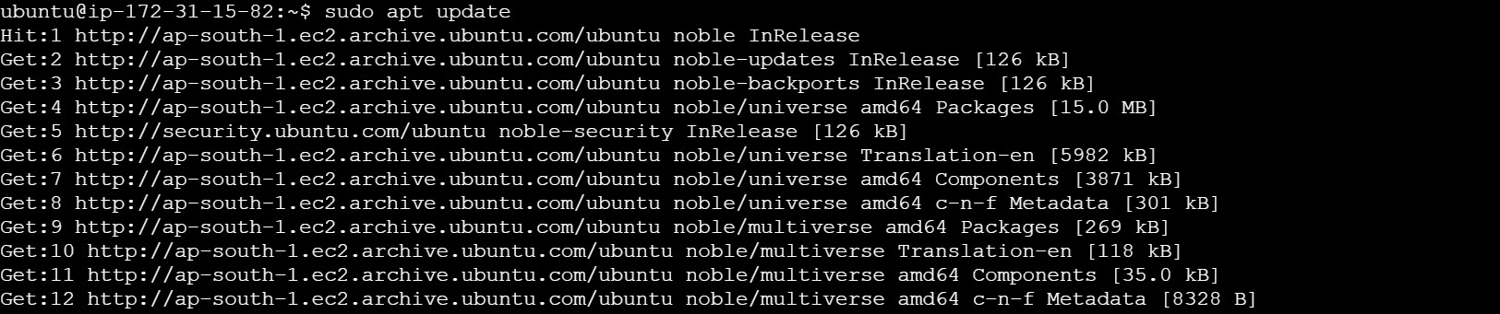

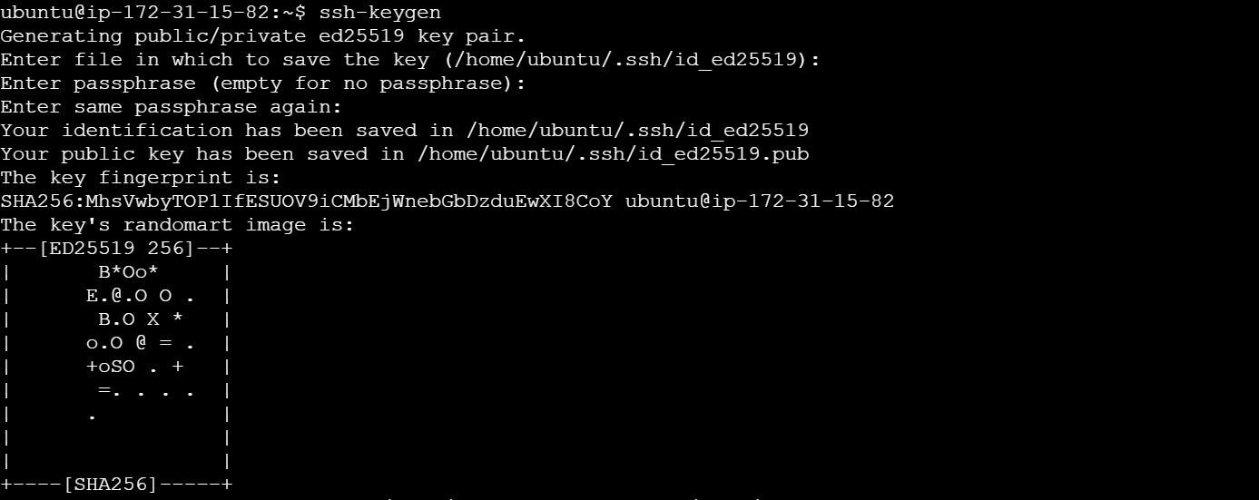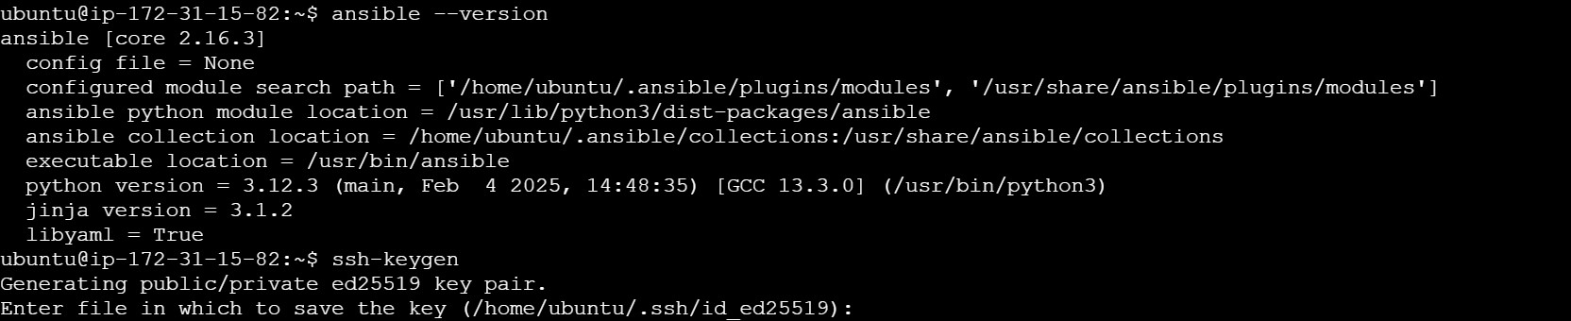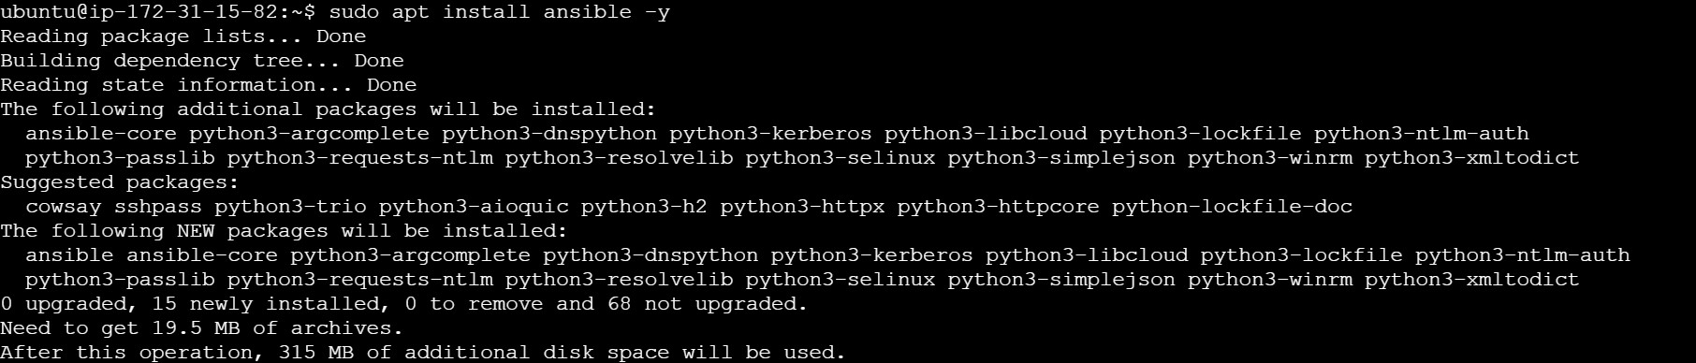 **Step 2: Generate SSH keypair on main node**

**Step 3: Copy SSH key to the other two nodes**

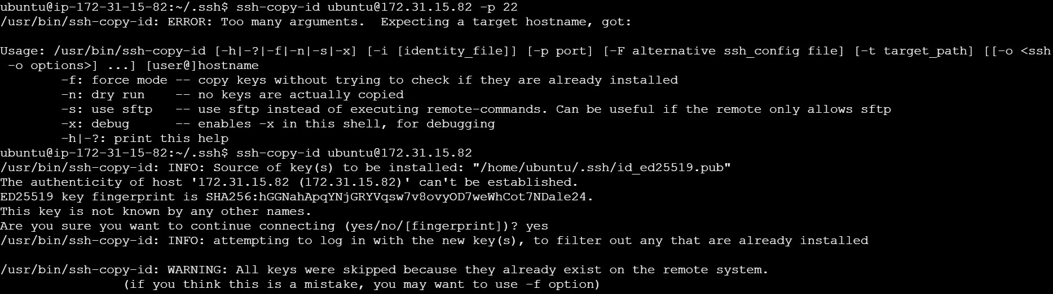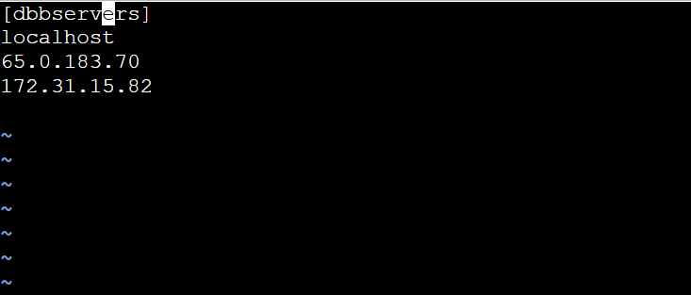**Step 4: Update the inventory or the host file with the host IP address**

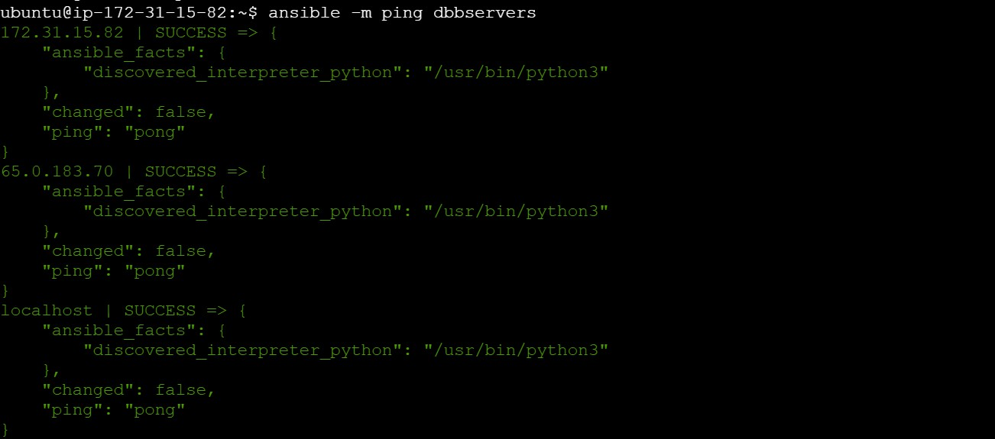**Step 5: Establish connectivity between the host specified in the host file and the ansible server**

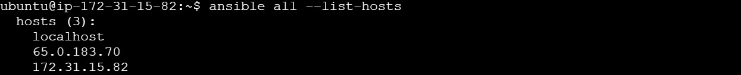

By following these steps, you have successfully created a static host inventory for managing and automating infrastructure tasks efficiently across multiple servers using Ansible.